CTE(Custom Terrain Editor)使用说明

Custom Terrain Editor(CTE) support for the FBX model
editing. This system is very similar to Unity's own terrain system, you will be very easy to use CTE. The current version not support change tree and grass position when change the terrain height.
First, add "Compoent -> CTE " on your terrain;Then, you can edit your terrain.
Custom Terrain Editor简称CTE，支持FBX模型的编辑，其完全模仿Unity自带地形系统，如果你使用过自带的地形系统，你将会很容易上手。目前暂不支持改变地形高度的同时改变树和草的位置坐标。
使用之前你需要添加"Compoent -> CTE "到你的地形GameObject上面，然后你就可以使用CTE进行编辑了。

1.Height 高度
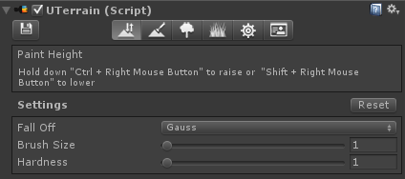
Hold down "Ctrl + Right Mouse Button" to raise or "Shift + Right Mouse Button\" to lower.
Property | Function
FallOff | FallOff mode  衰减模式设置
Brush Size | Size of the brush used to paint  笔刷尺寸大小
Hardness | Strength of the applied effect  笔刷权重值设定
Rest mesh to initial state.
重置Mesh到初始状态。

2.Texture 贴图(Support 4 Pass,支持4个通道设定)
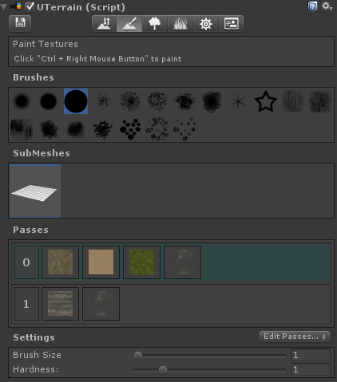
Click "Ctrl + Right Mouse Button" to paint.
点击“Ctrl + RightMouseButton”来刷贴图。
Property | Function
Brush Size | Size of the brush used to paint  笔刷尺寸大小
Hardness | Strength of the applied effect  笔刷权重值设定

3.Tree 树
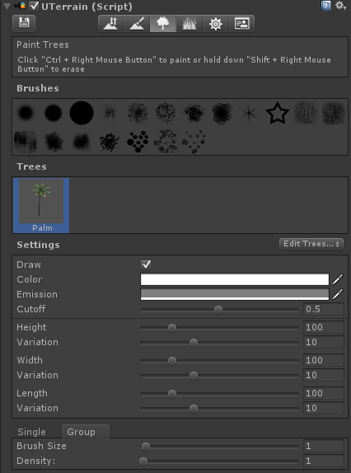
Click "Ctrl + Right Mouse Button" to paint or hold down "Shift + Right Mouse Button" to erase.
点击“Ctrl + RightMouseButton”来种植，按住“Shift + RightMouseButton”来删除。
Property | Function
Draw | Should selected tree be drawn?  是否显示当前所选树？
Color | BillboardTree's material main color.  公告牌材质的颜色设定。
Cutoff | BillboardTree's material cutoff value.  公告牌材质的Cutoff设定。
Emission | BillboardTree's material emission value.  公告牌材质的自发光颜色设定。
Height | Height of the tree.  树的高度设定。
Width | Width of the tree.  树的宽度设定。
Length | Length of the tree.  树的长度设定。
Variation | Variation of the tree size.  树大小的变化值。
Brush Size | Size of the brush used to paint.  笔刷尺寸大小。
Density | How dense trees are you painting.  树的密度设定。
4．Grass 草
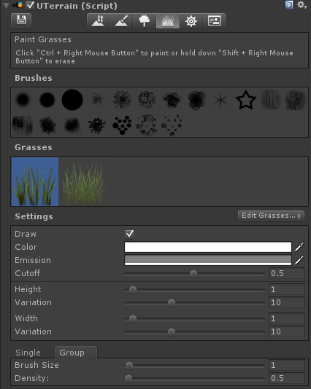
Property | Function
Draw | Should selected tree be drawn?  是否显示当前所选草？
Color | BillboardTree's material main color.  公告牌材质的颜色设定。
Cutoff | BillboardTree's material cutoff value.  公告牌材质的Cutoff设定。
Emission | BillboardTree's material emission value.  公告牌材质的自发光颜色设定。
Height | Height of the grass.  草的高度设定。
Width | Width of the grass.  草的宽度设定。
Variation | Variation of the tree size.  树大小的变化值。
Brush Size | Size of the brush used to paint  笔刷尺寸大小
Density | How dense grasses are you painting.  草的密度设定。

5．Settings 设置
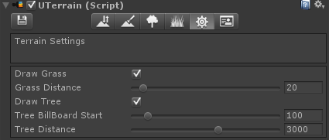
Property | Function
Draw Grass | Should all grasses be drawn?  是否显示当前所有草？
Grass Distance | The distance (from camera) beyond which grasses will be culled.  草的显示距离。
Draw Tree | Should all trees be drawn?  是否显示当前所有树？
Tree BillBoard Start | The distance (from camera) at which 3D tree objects will be replaced by billboard images.  公告牌树的起始距离。
Tree Distance | The distance (from camera) beyond which trees will be culled.  树的显示距离。

6.About 关于
